DFDS

Context Level Diagram for Onstream Troutville:

Onlsmart shopping management systemnemarketin
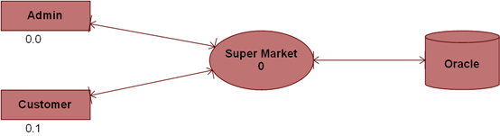

Level 1DFD for Admin:

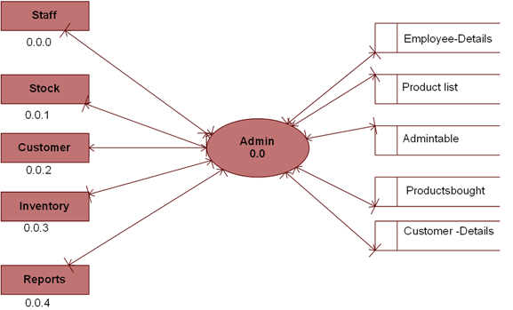

Level 1 DFD for Staff of Admin:

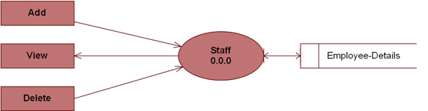

Level 1 for Stock of Admin:

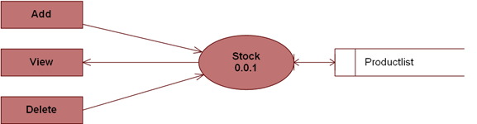

Level 1 DFD for Customer of Admin:

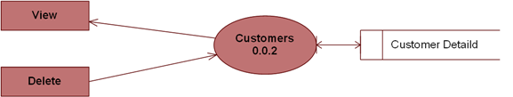

Level 1 DFD for Inventory of Admin:

